What is PySpark?

1. Pyspark is an interface for Apache Spark in Python.
2. Pyspark is a python library for distributed data processing and analysis.
3. It is a part of Apache spark project, which is a popular open-source distributed computing system for big data processing.
4. Pyspark provides a high-level API for distributed computing that enables users to analyse large datasets quickly and efficiently.
5. Pyspark is designed to run on top of spark’s distributed processing engine, which enables it to execute data processing tasks in parallel across a cluster of machines.
6. Pyspark can be used in a variety of application, including data warehousing, ETL(Extract, Transform, Load) processing, machine learning and real-time streaming.
7. Pyspark can be run on a cluster of computers, making it scalable to handle very large datasets.
8. Pyspark can be run on a variety of platforms, including Windows, Linux, macOS.

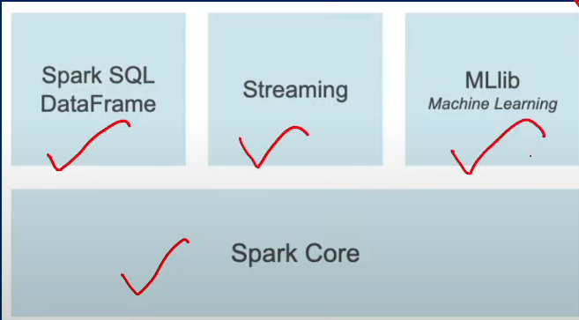

Pyspark in Data Engineering:

PySpark is commonly used in data engineering to process large volumes of data, transform data, and prepare data for downstream analysis. Here are some examples of how PySpark is used in data engineering:

1. Data Processing and Transformation: PySpark can be used to process large amounts of data and transform it into the desired format. For example, if you have a large dataset stored in a file format like CSV, PySpark can be used to read in the data, transform it, and save it to a different file format such as Parquet or ORC, which are optimized for big data processing.
2. Data Cleaning: PySpark can also be used for data cleaning tasks such as removing missing or duplicated data, normalizing data, and more. For example, you can use PySpark to identify and remove duplicate records in a dataset, or to standardize the format of date and time values.
3. Data Aggregation: PySpark can be used for data aggregation tasks such as computing summary statistics, performing group-by operations, and more. For example, you can use PySpark to group customer transactions by product and compute the total revenue for each product.
4. Data Integration: PySpark can also be used to integrate data from multiple sources. For example, if you have data stored in multiple databases or data lakes, PySpark can be used to extract the data, transform it, and load it into a single database or data lake.
5. Machine Learning: PySpark also has built-in support for machine learning tasks such as clustering, classification, and regression. For example, you can use PySpark to build a machine learning model that predicts customer churn based on demographic and behavioral data.